



GIZ4_AIS5_S1
AI & data science
Microsoft Data Engineer
Team 4

Urban Transit ETL Pipeline

ID | Name | Email | Phone Number
21126179 | Mohammed Khaled Ahmed | m.khaled306060@gmail.com | 01099982280
21128614 | Mohammed Ezzat Mohammed | ezatm1083@gmail.com | 01093682463
21090942 | Rokaya Mohammed Elsaid Ahmed | rokayamohameed22@gmail.com | 01067883391
21086309 | Ahmed Ayman Soliman | ahmed.ayman30@msa.edu.eg | 01555364886
21038541 | May Mohammed Massoud | mym559119@gmail.com | 01141173675
21088874 | Yousef Loley Abdelrahman | yousefloley@gmail.com | 01152803245
Table of Contents
1. Project Planning & Management 4
1.1 Project Proposal 4
1.1.1 Project Overview 4
1.1.2 Objectives 4
1.1.3 Project Scope 4
1.1.4 Tools & Technologies 5
1.2 Project Plan – Timeline & Milestones 5
Milestone Descriptions 6
1.3. Task Assignment & Team Roles 7
Project Manager Responsibilities 7
1.4. Risk Assessment & Mitigation Plan 8
Risk Management Approach 8
1.5. Key Performance Indicators (KPIs) 9
How KPIs Will Be Tracked 9
2. Literature Review 9
Suggested Improvements 9
Final Grading Criteria 10
3. Requirements Gathering 11
Stakeholders Analysis 11
User Stories and Use Cases 11
Functional Requirements 12
Non-Functional Requirements 12
4. System Analysis & Design 13
4.1 Problem Statement & Objectives 13
Problem Statement 13
Objectives 13
4.2 Functional & Non-Functional Requirements 14
4.2.1 Functional Requirements 14
4.2.2 Non-Functional Requirements 15
4.3 Use Case Diagram & Descriptions 17
1. Configure Pipeline 17
1.1 Brief description 17
1.2 Flow of Events 17
2.2 Flow of Events 19
2.3 Special Requirements 20
2.4 Pre-Conditions 20
2.5 Post-Conditions 21
2.6 Extension Points 21
4.4.1 Architectural Overview 41
4.4.2 Architectural Style 41

1. Project Planning & Management

1.1 Project Proposal

1.1.1 Project Overview
This project proposes developing a modern ETL (Extract, Transform, Load) pipeline using open-source data sets. The pipeline will extract data from raw CSV files, clean and transform it using Python-based libraries (Polars/Pandas), store it as Parquet files for optimal storage, and Sequelize will load the data into Google BigQuery to make it ready for analysis within BigQuery.

1.1.2 Objectives
- Finding and obtaining data from a reputable public data source (e.g., transportation data/location data/weather data).
- Dealing with missing or bad data using Python.
- Saving data as Parquet files for better performance.
- Uploading transformed data into Google BigQuery.
- Automating the ETL pipeline to run on a scheduled basis.
- Writing comprehensive technical documentation including schemas and BigQuery tables.

1.1.3 Project Scope
In Scope:
- Retrieves data from only one public CSV data source.
- Processes data through the various stages of the pipeline: cleanup, transformation, converting to parquet format.
- Uploads data into one BigQuery dataset.
- Automates the above processes using a tool(s).
- Provide complete documentation, presentations, and demos.
Out of Scope:
- Real-time streaming pipelines.
- Machine Learning models & advanced analysis of data.
- Production-ready deployments & associated cloud infrastructure costs except for free tiers.

1.1.4 Tools & Technologies
- Language: Python 3.x
- Data Processing: Polars / pandas
- Storage Format: Parquet
- Cloud Database: Google BigQuery (free tier)
- Scheduling: cron / Apache Airflow
- Version Control: GitHub
- Documentation: GitHub README + PDF Report

1.2 Project Plan – Timeline & Milestones
The time frame of this project is 11 weeks long (April 2nd to July 17th), with 5 milestones that are to be completed for this course to receive a passing grade
Milestone | Task | Start Date | End Date | Duration | Assigned To
M1 | Data Collection & Preprocessing | Apr 27, 2026 | May 10, 2026 | 2 weeks | Rokaya Mohammed Elsaid Ahmed & May Mohammed Massoud
M2 | Transformation & Validation | May 11, 2026 | May 31, 2026 | 3 weeks | Mohammed Khaled Ahmed & Mohammed Ezzat Mohammed
M3 | Deployment & BigQuery Load | Jun 1, 2026 | Jun 21, 2026 | 3 weeks | Ahmed Ayman Soliman & Yousef Loley Abdelrahman
M4 | Automation & Monitoring | Jun 22, 2026 | Jul 5, 2026 | 2 weeks | Rokaya Mohammed Elsaid Ahmed & May Mohammed Massoud
M5 | Documentation & Final Presentation | Jul 6, 2026 | Jul 17, 2026 | 2 weeks | Full Team

Milestone Descriptions
Milestone 1: Data Collection and Preprocessing (Weeks 1 and 2)
In the first phase of the project the data collection process to find a dataset to work with. At this time, we will download the entire dataset to our local machine for use during our ETL process. Once we have obtained the dataset, we will examine the data structure to identify any issues with the file formats as soon as possible, instead of waiting until later in the project. After this we will be converting the dataset that is in CSV format into the Parquet file format. The goal here is to increase the efficiency of our data collection process by using a file format that allows for faster loading and retrieval of information from the dataset.
Milestone 2: Transformation and Validation (Weeks 3 - 5)
In this phase of the project, we begin building the transformation side of the ETL development process using Python (with the Polars and Pandas libraries) to include our business rules into the data transform. After completing the transformation, we will perform data validation processes to ensure the data is consistent, of acceptable quality and adheres to the defined business rules.
Milestone 3: Deployment and Loading into BigQuery (Weeks 6 - 8)
After we complete the transformation step, we will set up the batch pipeline and load the Parquet files into the BigQuery database. After we have completed the load, we will run queries on the dataset to ensure that all data was loaded into the database correctly and to verify that the data looks and can be queried correctly.
Milestone 4: Automation and Monitoring (Weeks 9 - 10)
At this point of the project, we will automate the pipeline to run independently of human intervention by scheduling cron jobs or using Apache Airflow. We will also monitor the pipeline to ensure that the jobs run successfully and that BigQuery has the most accurate and up to date information.
Milestone 5: Documentation and Final Presentation (Weeks 11 - 12)
The final phase of the project involves documenting all the steps involved in the ETL process including the table schemas and the workings of the pipeline. Additionally, the final presentation of the project will be created and provided to the appropriate stakeholders involved with this project. Develop detailed documents covering the following: ETL processes, table schemas, Pipeline flow, etc.
Upload all project files (including documentation) to your assigned GitHub repository.

1.3. Task Assignment & Team Roles
The following table includes a definition of each team members' role and the section of the documentation that each team member will be responsible for:
Name | Role | Assigned Section
Rokaya Mohamed | Project Manager | Project Planning & Management
Mohamed Khaled | Researcher | Literature Review
Mohamed Ezzat | Researcher | Literature Review
Mai Mohamed | Business Analyst | Requirements Gathering
Youssef Loly | System Analyst | System Analysis & Design
Ahmed Soliman | System Analyst | System Analysis & Design

Project Manager Responsibilities
- Oversee the overall project timeline and ensure deadlines are met.
- Coordinate communication between all team members.
- Prepare and maintain the Project Planning & Management documentation.
- Track progress against milestones and escalate issues when needed.
- Compile and review final deliverables before submission.

1.4. Risk Assessment & Mitigation Plan
The following risks have been identified for this project, along with their likelihood, potential impact, and proposed mitigation strategies:
Risk | Likelihood | Impact | Mitigation Plan
Lack of technical background in data engineering | High | High | Use beginner-friendly tutorials; break tasks into small steps
Delays from team members on other sections | Medium | Medium | Set internal deadlines 1 week before official deadline
Data quality issues in open datasets | Medium | High | Validate data during Milestone 1; choose reliable sources
BigQuery setup difficulties | Medium | High | Use free trial; follow official Google documentation
Pipeline scheduling failures | Low | Medium | Implement error alerts and retry mechanisms

Risk Management Approach
- Risks will be reviewed at the start of each milestone.
- Any new risks identified during the project will be added to this document.
- The Project Manager is responsible for monitoring and escalating risks.

1.5. Key Performance Indicators (KPIs)
The following KPIs will be used to measure the success of the ETL Pipeline project:
KPI | Target | Measurement Method
Pipeline execution success rate | ≥ 95% | Pipeline run logs
Data completeness after transformation | 100% of rows loaded | Row count comparison before/after
Pipeline processing time | < 10 minutes per run | Execution time logs
BigQuery query response time | < 5 seconds | Manual query testing
Documentation completeness | All sections submitted | Checklist review
Final submission on time | By July 17, 2026 | Submission timestamp

How KPIs Will Be Tracked
- Pipeline logs will be reviewed after each scheduled run to check success rate and processing time.
- Row counts will be compared between the source CSV and the loaded BigQuery table to verify data completeness.
- BigQuery queries will be manually tested to measure response time.
- A documentation checklist will be reviewed before the final submission deadline.

2. Literature Review

Suggested Improvements
Based on the initial scope of the project, the following are areas where the project can be enhanced in future iterations:
- Real-time Processing: While the current pipeline operates on a scheduled batch basis , a future enhancement could involve upgrading to real-time streaming pipelines to handle live data feeds.
- Advanced Analytics: Once the data is successfully loaded into Google BigQuery , the system could be improved by performing advanced data analysis.
- Multiple Data Sources: The current scope is limited to a single CSV source. Expanding the extraction phase to ingest and join data from multiple diverse public APIs or databases would increase the pipeline's complexity and value.
- Production Infrastructure: The current architecture relies heavily on free-tier cloud databases. Transitioning the pipeline to fully production-ready deployments with managed cloud infrastructure would be a robust upgrade.

Final Grading Criteria
The breakdown of marks for this project will be evaluated across the following four core pillars:
- Documentation (25%): Evaluated on the completeness of the GitHub README, the PDF report , and the thoroughness of the schemas and BigQuery table documentation.
- Implementation (35%): Assessed on the successful execution of the ETL pipeline, specifically the efficient transformation of data using Polars/Pandas and the proper conversion into the Parquet storage format.
- Testing & Quality Assurance (20%): Graded on meeting the defined Key Performance Indicators (KPIs), such as achieving a pipeline execution success rate of 95% or higher and ensuring 100% data completeness after transformation.
- Presentation (20%): Based on the final deliverables, including the clarity and professionalism of the complete documentation, presentations, and demos.

3. Requirements Gathering

Stakeholders Analysis
Stakeholder | Roles/Responsibilities | Needs/Expectations
Data Analysts & BI Developers | Data Consumers | Clean, structured and performant datasets in BigQuery for reporting purposes and dashboarding
Data Engineers | Data Developers | Pipeline stability (GCP), cost efficiency / usage of GCP and processing speed using current technologies (i.e., Polars).
Project Managers | Decision Makers | Timeliness and accuracy of data for making critical business decisions
Cloud Architects | Infrastructure | Use of cloud infrastructure (resource usage and security of service account credentials)

User Stories and Use Cases
- User Story 1: As a Data Analyst, I want the pipeline to automatically handle the different data types (integer, date, string) so that I do not have to cast them manually when analyzing data.
- User Story 2: As a Data Engineer, I would like to be able to use Polars for transformations so that the pipeline can process millions of rows in seconds instead of minutes.
- User Story 3: As a System Administrator, I would like to be notified or receive log report of any failure with the daily data load so I can take action immediately.

Functional Requirements
- The system will accept raw CSV files from specified source directories or remote URLs (This is referred to as "Data Ingest" in the following).
- The system will automatically "clean" the data. That is, it will handle missing (NULL) values and duplicate data records.
- The system will verify that the incoming data structure conforms to the expected data format before any processing occurs (This requirement is referred to as "Schema Validation".).
- The raw CSV data will be converted into the Apache Parquet data format; this provides improved storage efficiency and query performance.
- The processed Parquet files will be programmatically loaded into a designated Google BigQuery table.
- The system should have the ability to run on a schedule to allow for a consistent way to keep the data updated.

Non-Functional Requirements
- Performance: The transformation logic will use multi-threaded processing
(via Polars) to efficiently process large datasets
- Idempotency: Re-running the pipeline with the same input data will not result in duplicate records in the final BigQuery destination.
- Scalability: The architecture will be able to add to the amount of data and maintain the core logic without requiring large amounts of re-engineering work.
- Cost: Use of the Parquet data format for data storage, and loading of data in a manner that minimizes computing and storage on the Google Cloud Platform.
- Reliability: All ERROR and INFO logging and ERROR reporting for the entire pipeline will be in place to ensure that the pipeline functions as expected.

4. System Analysis & Design

4.1 Problem Statement & Objectives

Problem Statement
The problem is that urban transit systems produce a lot of operational data every day. The operational data include various types of data, such as trip data, route data, timestamps, and station activity data. Open data platforms provide access to these large amounts of operational data, but often they are not easily accessible by those wanting to use them because they have limitations (like data quality issues such as missing values, duplicated records, inconsistent data types) associated with them that prevent users from effectively utilizing the data. In addition to the data quality issues, CSV files are not optimized for large data sets or analytical query processing and therefore are inefficient when working with high-volume data sets. Furthermore, differences in schema (structure) across various sources of data make it difficult to standardize and merge all the data into a common structure. As well as being time-consuming and error-prone, manual data processing creates a huge barrier to stakeholders such as data analysts and decision-makers who need clean, well-structured, and reliable data to conduct accurate analyses and provide insights. When there is not an automated process available, ensuring that the data is consistent, up-to-date, and scalable becomes increasingly difficult as the volume of data increases.

Objectives
This document is intended to be a project plan for developing a modern, automated ETL pipeline for processing urban public transit data. The pipeline will take raw, unstructured CSV datasets from the open data sets and convert them into a clean, structured and analytics ready database in a scalable cloud environment.
The objectives for this project will focus on 3 main areas: (1) the ability to ingest non-transformed (raw) CSV data from the open data sources in a credible / repeatable way; (2) a robust data cleaning and validating process including how to handle missing values, duplicates and ensuring consistency of the dataset’s schemas; (3) the ability to transform large amounts of data as quickly as possible using high performance data processing technologies such as Polars. Once the datasets have been transformed, they will be converted into Parquet format (a columnar format) for better optimized storage and improved query performance.
Additionally, the processed data will be transferred to Google BigQuery, which is a cloud-based data warehouse that can handle both fast and scalable query and analytical performance. For workload management, the batch processing pipeline will be created to run automatically with scheduling tools such as Cron jobs and/or Apache Airflow.
To monitor the system and make performance of each pipeline visible, monitoring and logging mechanisms will be built within each pipeline. Once completed, this project will provide an efficient and scalable data engineering solution that will support data driven decision-making in a transportation network.

4.2 Functional & Non-Functional Requirements

4.2.1 Functional Requirements
The functional requirements define the core operations that the Urban Transit ETL Pipeline system must perform to ensure successful data ingestion, processing, and delivery.

FR1: Data Ingestion
The system shall ingest raw CSV data from specified data sources, including local directories and remote URLs, in a reliable and repeatable manner.

FR2: Schema Validation
The system shall validate the structure of the ingested data by checking column names, data types, and required fields against a predefined schema before processing.

FR3: Data Cleaning
The system shall perform automated data cleaning operations, including handling missing values (NULLs), removing duplicate records, and filtering invalid data entries.

FR4: Data Transformation
The system shall transform the data using predefined rules, including standardizing formats, correcting data types, and generating derived attributes required for analysis.

FR5: Format Conversion
The system shall convert the processed dataset from CSV format into Apache Parquet format to optimize storage efficiency and query performance.

FR6: Data Loading to BigQuery
The system shall load the processed Parquet files into a designated Google BigQuery dataset and table for analytical querying.

FR7: Batch Scheduling
The system shall support automated execution of the ETL pipeline based on predefined schedules using tools such as cron jobs or Apache Airflow.

FR8: Logging and Monitoring
The system shall generate detailed logs for each pipeline execution, including execution status, errors, processing time, and data statistics.

FR9: Query Support
The system shall allow Data Analysts to query processed data stored in BigQuery using SQL for analytical purposes.

FR10: Reporting and Dashboard Integration
The system should support integration with reporting and dashboard tools to enable visualization of processed data.

4.2.2 Non-Functional Requirements
The non-functional requirements define the quality attributes and constraints of the system to ensure performance, scalability, and reliability.

NFR1: Performance
The system should utilize high-performance data processing tools such as Polars with multi-threading capabilities to efficiently process large datasets within acceptable time limits.

NFR2: Scalability
The system shall be capable of handling increasing data volumes without requiring significant changes to the system architecture.

NFR3: Reliability
The system shall ensure reliable execution through detailed logging, error handling, and failure detection mechanisms to support pipeline observability.

NFR4: Idempotency
The system shall guarantee that re-running the pipeline with the same input data does not result in duplicate records in the BigQuery destination.

NFR5: Cost Efficiency
The system will optimize storage and processing costs by using efficient data formats such as Parquet and minimizing unnecessary data processing operations in Google Cloud.

NFR6: Security
The system shall ensure secure access to BigQuery using authenticated service accounts and proper permission management.

NFR7: Maintainability
The system should be modular and well-structured to allow easy updates, debugging, and extension of pipeline components.

NFR8: Usability
The system should provide clear logs and simple monitoring interfaces to allow users to easily understand pipeline status and execution results.

4.3 Use Case Diagram & Descriptions
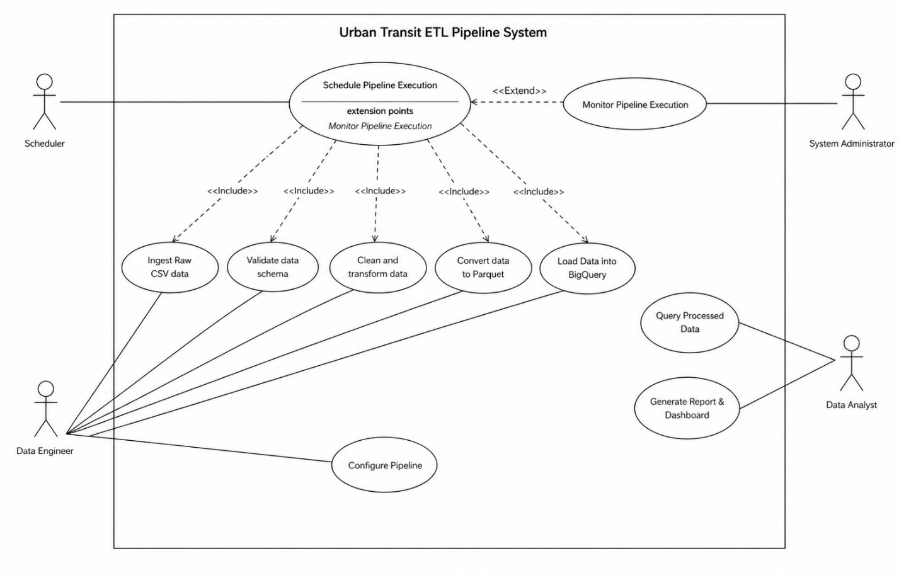

1. Configure Pipeline

1.1 Brief description
This situation permits the Data Engineer to set up the ETL pipeline by specifying the data sources, schema structure, transformation rules, output format, and the destination in BigQuery.

1.2 Flow of Events

1.2.1 Basic Flow
This situation starts when the Data Engineer indicates they want to Set up the ETL Pipeline.
1. The system prompts the Data Engineer for the following parameters for configuration:
- The location of the data source (local file or remote via URL)
- The anticipated schema (column names and data types)
- The data cleaning and transformation rules to be applied to the data
- The output will be in Parquet format
- The target BigQuery dataset and table to contain the processed data
2. The Data Engineer provides the information requested for all of the configuration parameters.
3. The system verifies the data provided in all configuration parameters.
4. The system saves the configuration parameters used to configure the ETL pipeline.
5. The system indicates the setup of the ETL pipeline with the specified configuration parameters has been completed successfully and is ready to be executed.

1.2.2 Alternative Flows

1.2.2.1 Invalid Configuration Input Flow
If the data engineer attempts to configure an ETL pipeline and provides an invalid or incomplete file or schema, then the following should occur: 1) An error message should be provided; 2) The data engineer will be prompted to correct the input; 3) The flow should return to Step 2 of the Basic Flow.

1.2.2.2 Unavailable Data Source Flow
If the specified data source cannot be accessed: 1) An error message should be generated to notify the data engineer of a connection or file error; 2) The data engineer will either have the option to update the data source or cancel the configuration; and 3) If the configuration is canceled, the flow will terminate.

1.3 Special Requirements
- The system must support local or remote as specified in the ETL pipeline configuration.
- The configuration process must be user-friendly, easy to navigate; and provide clarity of process to the data engineer.
- Schema and destination validation must be enforced before a configuration can be saved.

1.2.4 Preconditions
- A data engineer must be authenticated and have access to the system.
- All dependencies (e.g., BigQuery, file systems) must be resolved before configuring an ETL pipeline.

1.2.5 Postconditions
- The ETL pipeline is configured and saved successfully.
- The system is now able to execute the ETL pipeline as defined in the saved configuration.

1.2.6 Extension Points
- Validate configuration inputs
- Validate data source connection2. Schedule Pipeline Execution
2.1 Brief Description
The use case allows the Scheduler to automatically trigger the ETL pipeline at predefined time intervals to ensure continuous and consistent data processing.

2.2 Flow of Events

2.2.1 Basic Flow
The use case begins when the scheduled execution time is reached.
- The Scheduler triggers the ETL pipeline based on the predefined schedule.
- The system retrieves the saved pipeline configuration.
- The system initiates the ETL execution process, which includes:
  - Ingesting raw CSV data,
  - Validating data schema,
  - Cleaning and transforming data,
  - Converting data to Parquet format,
  - Loading data into BigQuery.
- The system generates execution logs during the pipeline process.
- Upon successful completion, the system updates the execution status as “Success”.
- The system stores execution logs and timestamps for monitoring and auditing purposes.

2.2.2 Alternative Flows

2.2.2.1 Pipeline Execution Failure
If an error occurs during any stage of the ETL process:
- The system stops pipeline execution.
- The system logs the error details.
- The system updates the execution status as “Failed”.
- The System Administrator is notified to investigate the issue.

2.2.2.2 Missing Configuration
If no valid pipeline configuration is found:
- The system aborts the execution process.
- The system logs an error indicating missing configuration.
- The System Administrator or Data Engineer must configure the pipeline before re-execution.

2.2.2.3 Scheduler Failure
If the Scheduler fails to trigger the pipeline:
- The execution is skipped.
- The failure is logged.
- The System Administrator may manually trigger the pipeline.

2.3 Special Requirements
- The scheduling mechanism should support periodic execution (e.g., hourly, daily).
- The system must ensure idempotency to avoid duplicate data loading.
- Execution logs must be generated for each run.

2.4 Pre-Conditions
- The pipeline configuration has been successfully defined.
- The Scheduler is properly configured and active.
- Required system resources (data source, storage, BigQuery access) are available.

2.5 Post-Conditions
- The ETL pipeline is executed according to the schedule.
- Processed data is loaded into BigQuery (if execution is successful).
- Execution logs and status are stored for monitoring.

2.6 Extension Points
- Pipeline execution monitoring
- Error handling and logging
- Notification mechanism for failures
3. Ingested in Raw Data from A CSV
3.1 Brief Description
This use case provides the opportunity for the system to pull raw urban transit data in CSV format either from a location on disk (local) or through an open remote data source.
3.2 Flow of Event
3.2.1 Basic Flow
- This case begins when ETL begins the processing stage of ingesting data.
- Retrieve Data Source Location Configuration - The system retrieves the defined Data Source Location for further processing of the identified Source data items.
- Verify Accessibility to Data Source - The system verifies availability of the identified data source (for example: An Identified Source is either CSV file(s), or a remote data source).
- Read Raw CSV Data - The system reads the raw urban transit data that has been populated into the specified source location.
- Determine File Structure - The system identifies the file structure (for example: columns, column delimiters, column encoding, etc.) of the source CSV data that is identified in this step and is being processed.
- Load Raw Data - The system loads the source CSV file data into system memory (or into a system dataframe to allow for further processing).
- Pass Data to Schema Validation Stage - The system passes the ingested data to the Schema Validation stage of processing.
3.2.2 Alternative Flows
3.2.2.1 Data Source Not Found
If the configured CSV file or remote source is not found:
- The system displays or logs data source errors.
- The ingestion process stops.
- The pipeline execution status is marked as “Failed”.
3.2.2.2 Invalid CSV Format
If the file is corrupted or not readable as a valid CSV file:
- The system logs the parsing error.
- The ingestion process is stopped.
- The Data Engineer must provide a valid CSV file.
3.2.2.3 Empty CSV File
If the CSV file contains no records:
- The system logs a warning.
- The pipeline execution is stopped or skipped based on configuration.
- No data is passed to the next stage.
3.3 Special Requirements
- The system should support CSV files from local paths or remote URLs.
- The system should handle common CSV settings such as delimiter, encoding, and headers.
- The ingestion process should be efficient for large datasets.
3.4 Pre-Conditions
- The pipeline configuration exists.
- The data source location is defined.
- The CSV file or remote URL is accessible.
3.5 Post-Conditions
- Raw CSV data is successfully loaded into the pipeline.
- The ingested data is ready for schema validation.
- Ingestion logs are generated.
3.6 Extension Points
- Data source accessibility check
- CSV parsing validation
- Empty file detection
4. Validate Data Schema
4.1 Brief Description
The use case allows the system to verify that the ingested CSV data matches the expected schema, including column names, number of columns, data types, and required fields.
4.2 Flow of Events
4.2.1 Basic Flow
The use case begins after the raw CSV data has been successfully ingested.
- The system retrieves the expected schema from the pipeline configuration.
- The system reads the actual schema of the ingested dataset.
- The system compares the actual column names with the expected column names.
- The system checks whether all required columns are available.
- The system verifies that each column has the correct data type, such as integer, string, date, timestamp, or float.
- The system checks for schema inconsistencies, such as missing columns, extra columns, or incorrect data types.
- If the schema is valid, the system marks the validation status as “Passed”.
- The system passes the validated dataset to the data cleaning and transformation stage.
4.2.2 Alternative Flows
4.2.2.1 Missing Required Columns
If one or more required columns are missing:
- The system logs the missing column names.
- The validation status is marked as “Failed”.
- The pipeline execution is stopped until the schema issue is corrected.
4.2.2.2 Incorrect Data Types
If one or more columns have incorrect data types:
- The system attempts to cast value to the expected data type if conversion is safe.
- If conversion succeeds, the flow returns to Step 5 of the Basic Flow.
- If conversion fails, the system logs the invalid column names and values.
- The validation status is marked as “Failed”.
4.2.2.3 Extra Columns Detected
If the dataset contains additional columns not defined in the expected schema:
- The system logs the extra column names.
- The system either ignores the extra columns or keeps them based on configuration.
- The validation process continues.
4.3 Special Requirements
- The system must validate schema before transformation begins.
- The expected schema should be stored in the pipeline configuration.
- Schema validation results must be logged for auditing and debugging.
- The system should support safe type casting when possible.
4.4 Pre-Conditions
- Raw CSV data has been successfully ingested.
- The expected schema is defined in the pipeline configuration.
- The ingested dataset is readable by the processing engine.
4.5 Post-Conditions
- The dataset schema is validated successfully, or validation errors are recorded.
- Invalid datasets are prevented from moving to the transformation stage.
- Valid datasets are passed on to the cleaning and transformation process.
4.6 Extension Points
- Missing column detection
- Data type validation
- Safe type casting
- Extra column handling
5. Clean and Transform Data
5.1 Brief Description
The use case allows the system to clean and transform the validated urban transit dataset by handling missing values, removing duplicate records, correcting data types, standardizing formats, and preparing the data for optimized storage.
5.2 Flow of Events
5.2.1 Basic Flow
The use case begins after the dataset schema has been successfully validated.
- The system receives the validated dataset from the schema validation stage.
- The system identifies data quality issues such as missing values, duplicate records, invalid values, and inconsistent formats.
- The system handles missing values based on predefined cleaning rules.
- The system removes duplicate records to prevent repeated data in the final destination.
- The system corrects and standardizes data types, such as dates, timestamps, numeric values, and text fields.
- The system applies transformation rules using Polars, such as renaming columns, filtering invalid records, creating derived fields, or formatting timestamps.
- The system validates the transformed dataset to ensure that the output is complete and consistent.
- The system passes the cleaned and transformed dataset to the Parquet conversion stage.
5.2.2 Alternative Flows
5.2.2.1 Missing Values Exceed Allowed Threshold
If the number of missing values exceeds the accepted threshold:
- The system logs the affected columns and missing value percentage.
- The transformation process is stopped or flagged for review.
- The Data Engineer reviews the cleaning rules before re-execution.
5.2.2.2 Duplicate Records Detected
If duplicate records are detected:
- The system removes duplicate records according to the configured deduplication rules.
- The system logs the number of removed records.
- The cleaning process continues.
5.2.2.3 Invalid Values Detected
If invalid values are detected, such as negative trip duration or incorrect timestamp values:
- The system applies predefined validation rules.
- Invalid records are removed, corrected, or flagged depending on configuration.
- The system logs the invalid records for auditing.
5.2.2.4 Transformation Rule Failure
If a transformation rule fails due to invalid logic or unsupported data format:
- The system logs the transformation error.
- The pipeline execution is marked as “Failed”.
- The Data Engineer must correct the transformation rule before re-running the pipeline.
5.3 Special Requirements
- The system should use Polars for efficient data cleaning and transformation.
- The cleaning rules must be configurable and reusable.
- The system must preserve data consistency after transformation.
- The transformation process should support large datasets efficiently.
- All cleaning and transformation actions must be logged.
5.4 Pre-Conditions
- The dataset schema has been successfully validated.
- Cleaning and transformation rules are defined in the pipeline configuration.
- The processing environment has sufficient resources to transform the dataset.
5.5 Post-Conditions
- The dataset is cleaned, transformed, and ready for Parquet conversion.
- Duplicate records, invalid values, and missing values are handled according to defined rules.
- Transformation logs are generated for monitoring and auditing.
5.6 Extension Points
- Missing value handling
- Duplicate record removal
- Data type standardization
- Invalid value detection
- Derived field generation
- Transformation error handling
6. Convert Data to Parquet
6.1 Brief Description
The use case allows the system to convert the cleaned and transformed dataset into Apache Parquet format to improve storage efficiency, reduce file size, and optimize query performance.
6.2 Flow of Events
6.2.1 Basic Flow
The use case begins after the data cleaning, and transformation stage has been completed successfully.
- The system receives a clean and transformed dataset.
- The system verifies that the dataset is complete and ready for export.
- The system defines the output Parquet file name and storage path.
- The system converts the dataset into Parquet format.
- The system applies compression to reduce storage size.
- The system saves the Parquet file in the processed data storage location.
- The system verifies that the Parquet file was created successfully.
- The system passes the Parquet file path to the BigQuery loading stage.
6.2.2 Alternative Flows
6.2.2.1 Empty Processed Dataset
If the cleaned dataset contains no valid records:
- The system logs a warning message.
- The Parquet conversion process is skipped.
- The pipeline execution is marked as “Skipped” or “Failed” based on configuration.
6.2.2.2 Parquet File Creation Failure
If the system fails to create the Parquet file:
- The system logs the file creation error.
- The pipeline execution is marked as “Failed”.
- The Data Engineer must investigate the storage or file-writing issue.
6.2.2.3 Storage Path Unavailable
If the output storage path is not available:
- The system logs a storage access error.
- The conversion process stops.
- The Data Engineer updates the storage path or permissions.
6.3 Special Requirements
- The system must store processed data in Apache Parquet format.
- The Parquet file should use compression to reduce storage size.
- The output file path and naming convention should be clearly defined.
- The Parquet file created must be readable by the BigQuery loading process.
- File creation status must be logged.
6.4 Pre-Conditions
- The data cleaning and transformation process has been completed successfully.
- The processed dataset is available in memory or temporary storage.
- The output storage path is configured and accessible.
6.5 Post-Conditions
- A Parquet file is successfully created.
- The processed dataset is stored in an optimized columnar format.
- The Parquet File Path is available for the BigQuery loading stage.
- Conversion logs are generated.
6.6 Extension Points
- Processed dataset completeness check
- Output path validation
- Parquet file creation
- Compression handling
- File creation verification
7. Load Data into BigQuery
7.1 Brief Description
The use case allows the system to load the processed Parquet data into Google BigQuery, enabling structured storage and high-performance analytical querying.
7.2 Flow of Events
7.2.1 Basic Flow
The use case begins after the Parquet file has been successfully created.
- The system retrieves the Parquet file path and the target BigQuery dataset and table from the configuration.
- The system authenticates with Google BigQuery using the configured service account credentials.
- The system establishes a connection to the BigQuery environment.
- The system checks whether the target dataset and table exist.
- If the table exists, the system prepares the appropriate load mode (append or overwrite).
- The system uploads the Parquet file to BigQuery.
- BigQuery processes and loads the data into the target table.
- The system verifies that the data has been successfully loaded.
- The system updates the pipeline execution status as “Success”.
- The system logs the load operation details, including row count and timestamp.
7.2.2 Alternative Flows
7.2.2.1 Authentication Failure
If authentication with BigQuery fails:
- The system logs the authentication error.
- The loading process stops.
- The pipeline execution is marked as “Failed”.
7.2.2.2 Dataset or Table Not Found
If the specified dataset or table does not exist:
- The system logs the missing resource error.
- The system may create the dataset/table if auto-creation is enabled.
- Otherwise, the process stops and requires manual intervention.
7.2.2.3 Data Load Failure
If the data upload or load process fails:
- The system logs the load error details.
- The pipeline execution is marked as “Failed”.
- The Data Engineer investigates the issue.
7.2.2.4 Duplicate Data Risk
If the pipeline is re-executed with the same dataset:
- The system checks for duplicate records based on configured rules.
- The system prevents duplication by using append/overwrite logic or deduplication mechanisms.
- The process continues.
7.3 Special Requirements
- The system must securely authenticate with BigQuery.
- The system should support both append and overwrite loading modes.
- The load process must ensure idempotency to prevent duplicate records.
- The system should log load statistics such as row count and execution time.
- The Parquet format must be compatible with BigQuery ingestion.
7.4 Pre-Conditions
- The Parquet file has been successfully created.
- BigQuery dataset and table configuration are defined.
- Valid authentication credentials are available.
- Network access to BigQuery is available.
7.5 Post-Conditions
- Data is successfully loaded into the BigQuery table.
- The dataset is available for querying and analysis.
- Load operation logs are recorded.
- The pipeline execution status is updated.
7.6 Extension Points
- BigQuery authentication
- Dataset and table validation
- Load mode selection (append/overwrite)
- Data upload process
- Load verification and logging
8. Monitor Pipeline Execution
8.1 Brief Description
The use case allows the System Administrator to monitor the execution of the ETL pipeline by tracking logs, checking execution status, identifying failures, and ensuring that the pipeline operates reliably.
8.2 Flow of Events
8.2.1 Basic Flow
The use case begins when the pipeline execution is triggered or completed.
- The system generates execution logs for each stage of the ETL pipeline.
- The system records key execution details, including start time, end time, status (Success/Failed), and processed row counts.
- The System Administrator accesses the monitoring interface or log system.
- The system displays the pipeline execution status and logs.
- The System Administrator reviews the execution results.
- If the pipeline execution is successful, the system confirms normal operation.
- The monitoring process continues for future executions.
8.2.2 Alternative Flows
8.2.2.1 Pipeline Failure Detected
If the pipeline execution fails at any stage:
- The system logs the failure details, including error messages and failed stage.
- The system updates the execution status as “Failed”.
- The System Administrator is alerted.
- The System Administrator investigates and resolves the issue.
8.2.2.2 Performance Degradation
If the pipeline execution time exceeds the expected threshold:
- The system logs performance metrics.
- The System Administrator is notified of the delay.
- The performance issue is analyzed and optimized.
8.2.2.3 Missing or Incomplete Logs
If execution logs are missing or incomplete:
- The system logs a monitoring error.
- The System Administrator checks logging configuration.
- The issue is resolved before the next execution cycle.
8.3 Special Requirements
- The system must maintain detailed execution logs for all pipeline stages.
- The monitoring system should provide clear status indicators (Success, Failed, Running).
- The system should support alert mechanisms for failures.
- Execution metrics such as processing time and row counts must be recorded.
8.4 Pre-Conditions
- The ETL pipeline has been executed or is currently running.
- Logging mechanisms are properly configured.
- The System Administrator has access to monitoring tools or logs.
8.5 Post-Conditions
- Pipeline execution status is recorded and available.
- Logs are stored for auditing and debugging.
- Any detected issues are identified and addressed.
8.6 Extension Points
- Execution logging
- Failure detection
- Alert notification
- Performance monitoring
- Log validation
9. Query Processed Data
9.1 Brief Description
The use case allows the Data Analyst or BI Developer to query the processed and structured data stored in Google BigQuery to retrieve insights for analysis and reporting.
9.2 Flow of Events
9.2.1 Basic Flow
The use case begins when the Data Analyst requests to query processed data.
- The Data Analyst accesses the BigQuery environment.
- The system displays available datasets and tables.
- The Data Analyst selects the relevant dataset and table.
- The Data Analyst writes an SQL query to retrieve specific data.
- The system validates the query syntax.
- The system executes the query on BigQuery.
- The system retrieves and displays the query results.
- The Data Analyst reviews the results for analysis purposes.
9.2.2 Alternative Flows
9.2.2.1 Invalid Query Syntax
If the SQL query contains syntax errors:
- The system displays an error message.
- The Data Analyst corrects the query.
- The flow returns to Step 4 of the Basic Flow.
9.2.2.2 Empty Result Set
If the query returns, there are no results:
- The system displays an empty result message.
- The Data Analyst may modify the query.
- The flow returns to Step 4 of the Basic Flow.
9.2.2.3 Query Execution Failure
If the query fails due to system or resource issues:
- The system logs the query error.
- The Data Analyst is notified.
- The query may be retried or modified.
9.3 Special Requirements
- The system must support standard SQL queries in BigQuery.
- Query execution should be optimized for performance.
- Access control must ensure only authorized users can query the data.
- Query execution logs should be maintained.
9.4 Pre-Conditions
- The data has been successfully loaded into BigQuery.
- The Data Analyst has access permissions to the dataset.
- BigQuery services are available.
9.5 Post-Conditions
- Query results are successfully retrieved and displayed.
- The Data Analyst obtains insights from the data.
- Query execution logs are recorded.
9.6 Extension Points
- Query validation
- Query execution
- Result retrieval
- Error handling
- Access control
10. Generate Report & Dashboard
10.1 Brief Description
The use case allows the Data Analyst or BI Developer to create reports and dashboards based on the processed data stored in Google BigQuery, enabling data visualization and decision-making.
10.2 Flow of Events
10.2.1 Basic Flow
The use case begins when the Data Analyst or BI Developer requests to generate a report or dashboard.
- The Data Analyst accesses the reporting or dashboard tool connected to BigQuery.
- The system displays available datasets and tables.
- The Data Analyst selects the relevant dataset and defines required metrics and dimensions.
- The system retrieves data from BigQuery using predefined or custom queries.
- The Data Analyst selects appropriate visualization types (charts, tables, graphs).
- The system generates the report or dashboard based on selected configurations.
- The Data Analyst reviews and refines the visualization (filters, sorting, formatting).
- The system saves the report or dashboard.
- The Data Analyst shares or exports the report/dashboard for stakeholders.
10.2.2 Alternative Flows
10.2.2.1 No Data Available
If no data is available in BigQuery:
- The system displays a “No Data Available” message.
- The Data Analyst verifies data loading or modifies the query.
10.2.2.2 Invalid Visualization Configuration
If the selected visualization is not compatible with the data:
- The system displays an error or warning.
- The Data Analyst selects a different visualization type.
- The flow returns to Step 5.
10.2.2.3 Data Retrieval Failure
If data cannot be retrieved from BigQuery:
- The system logs the error.
- The Data Analyst is notified.
- The issue is investigated or the query is retried.
10.2.2.4 Dashboard Save Failure
If the system fails to save the report/dashboard:
- The system displays a save error.
- The Data Analyst retries the operation or checks permissions.
10.3 Special Requirements
- The system should support integration with BI tools (e.g., dashboards connected to BigQuery).
- Visualizations must be interactive and user-friendly.
- The system should support filtering, sorting, and aggregation.
- Reports and dashboards should be shareable.
- Data must be refreshed based on pipeline updates.
10.4 Pre-Conditions
- Processed data is available in BigQuery.
- The Data Analyst has access to the reporting tool and dataset.
- Queries used for visualization are valid.
10.5 Post-Conditions
- Reports and dashboards are successfully generated.
- Visual insights are available for decision-making.
- Reports can be saved, shared, or exported.
10.6 Extension Points
- Data retrieval from BigQuery
- Visualization configuration
- Dashboard customization
- Report saving and sharing
- Error handling

4.4 Software Architecture
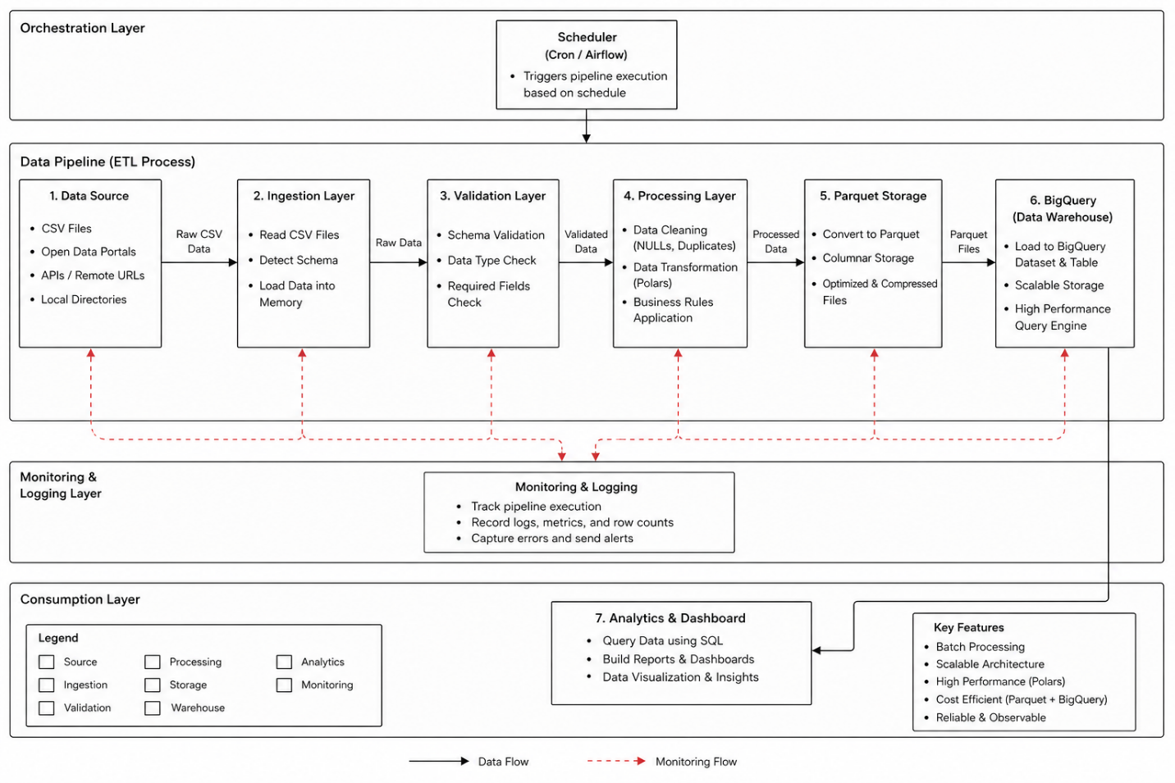

4.4.1 Architectural Overview
The Urban Transit ETL Pipeline uses a Batch ETL Pipeline architecture to process data through periodic scheduling rather than real-time processing. The system uses a modular layer design to ensure scalability, maintainability and efficient data processing.
The architecture has multiple distinct components, such as data ingestion, data validation, data transformation, data storage and data warehouse that are defined according to the specific role fulfilled by that component in the pipeline and allow for the pipeline to process large amounts of data efficiently.

4.4.2 Architectural Style
The system uses Batch Processing Architecture, meaning that:
- Data is collected periodically (e.g., daily or hourly).
- The execution of each pipeline will process a "batch" (or set) of data in its entirety when run.
- The system is orchestrated by utilizing a scheduling tool(such as cron jobs or Apache Airflow)
Through this approach to processing data, the Urban Transit ETL Pipeline ensures consistency, simplicity and reliability when handling large quantities of datasets.
4.4.3 System Components
The system is composed of the following main components:
1. Data Source Layer
This layer represents external data sources that provide raw CSV datasets. These sources may include open data platforms, APIs, or local storage.
2. Ingestion Layer
This component is responsible for:
- Reading raw CSV files
- Detecting file structure
- Loading data into the processing environment
3. Validation Layer
This layer ensures that:
- Data schema matches expected structure
- Required fields are present
- Data types are correct
4. Processing Layer
This is the core component of the system, responsible for:
- Data cleaning (handling NULLs, duplicates)
- Data transformation using Polars
- Applying business rules
5. Storage Layer (Parquet)
This layer handles:
- Conversion of processed data into Parquet format
- Efficient storage using columnar structure
- Temporary or intermediate storage
6. Data Warehouse Layer (BigQuery)
This component:
- Loads processed data into BigQuery
- Stores structured datasets
- Enables fast analytical queries
7. Orchestration Layer (Scheduler)
This layer is responsible for:
- Triggering pipeline execution
- Managing scheduling (cron / Airflow)
- Ensuring periodic data updates
8. Monitoring & Logging Layer
This component:
- Tracks pipeline execution status
- Records logs and errors
- Provides visibility into system performance

9. Analytics & Visualization Layer (Optional)
This layer allows:
- Querying data from BigQuery
- Generating dashboards and reports
- Supporting decision-making
4.4.4 Component Interaction
The interaction between components follows a sequential data flow:
- The Scheduler triggers the ETL pipeline execution.
- The Ingestion Layer reads raw CSV data from the Data Source Layer.
- The Validation Layer verifies the schema of the ingested data.
- The Processing Layer cleans and transforms the data.
- The Storage Layer converts the processed data into Parquet format.
- The Data Warehouse Layer loads the data into BigQuery.
- The Monitoring Layer logs execution details and detects failures.
- The Analytics Layer queries the data for reporting and visualization.
4.4.5 Architecture Diagram Description
To draw the architecture diagram:
Layers (from left to right):
Data Source → Ingestion → Validation → Processing → Parquet Storage → BigQuery → Analytics
Top Layer:
- Scheduler (connected to entire pipeline)
Bottom Layer:
- Monitoring & Logging (connected to all components)
4.4.6 Key Design Considerations
- Modularity: Each component is independent and can be modified without affecting the entire system.
- Scalability: BigQuery and Parquet allow handling large datasets efficiently.
- Performance: Use of Polars ensures fast data processing.
- Reliability: Logging and monitoring ensure failure detection and recovery.
- Cost Efficiency: Columnar storage and optimized queries reduce cloud costs.
4.5 Database Design & Data Modeling
4.5.1 Overview
The Urban Transit ETL Pipeline does not use a traditional transactional database. Instead, it stores the final processed data inside Google BigQuery, which acts as the analytical data warehouse. The database design focuses on making the data clean, structured, query-ready, and suitable for dashboards and reporting.
The pipeline starts with raw CSV files, then validates, cleans, transforms, and converts the data into Parquet format before loading it into BigQuery. This supports the requirement that processed Parquet files should be loaded into a designated BigQuery table.
4.5.2 Data Modeling Approach
The system uses an analytical data model instead of a normal operational database model. Since the goal is analysis and reporting, the recommended model is a Star Schema.
The Star Schema contains:
- Fact Table: stores measurable transit events or trip records.
- Dimension Tables: store descriptive information such as route, station, date, and vehicle.
- Pipeline Log Table: stores execution metadata for monitoring and auditing.
This design makes querying faster and easier for data analysts and BI developers.
4.5.3 Main Entities
1. Fact_Transit_Trips
This is the main fact table. It stores cleaned and processed transit trip records.
Attributes: (trip_id — Primary Key, route_id — Foreign Key, start_station_id — Foreign Key, end_station_id — Foreign Key, date_id — Foreign Key, vehicle_id — Foreign Key, start_time, end_time, trip_duration_minutes, passenger_count, fare_amount, load_timestamp).
2. Dim_Route
This table stores route information.
Attributes: (route_id — Primary Key, route_name, route_type, start_area, end_area).
3. Dim_Station
This table stores station or stop information.
Attributes: (station_id — Primary Key, station_name, city, latitude, longitude).
4. Dim_Date
This table supports time-based analysis.
Attributes: (date_id — Primary Key, full_date, day, month, quarter, year, day_of_week).
5. Dim_Vehicle
This table stores vehicle information.
Attributes: (vehicle_id — Primary Key, vehicle_type, capacity).
6. Pipeline_Run_Log
This table stores metadata about each ETL pipeline execution.
Attributes: (run_id — Primary Key, pipeline_name, start_time, end_time, status, rows_ingested, rows_processed, rows_loaded, error_message).
4.5.4 ERD Description
The ERD is designed around one central fact table: Fact_Transit_Trips.
Relationships:
- One route can have many trips.
Dim_Route 1 → Many Fact_Transit_Trips
- One station can appear in many trips as a start station.
Dim_Station 1 → Many Fact_Transit_Trips
- One station can appear in many trips as an end station.
Dim_Station 1 → Many Fact_Transit_Trips
- One date can be associated with many trips.
Dim_Date 1 → Many Fact_Transit_Trips
- One vehicle can be used in many trips.
Dim_Vehicle 1 → Many Fact_Transit_Trips
- One pipeline run can load many trip records.
Pipeline_Run_Log 1 → Many Fact_Transit_Trips
This relationship may be optional depending on implementation.

4.5.5 Logical Schema
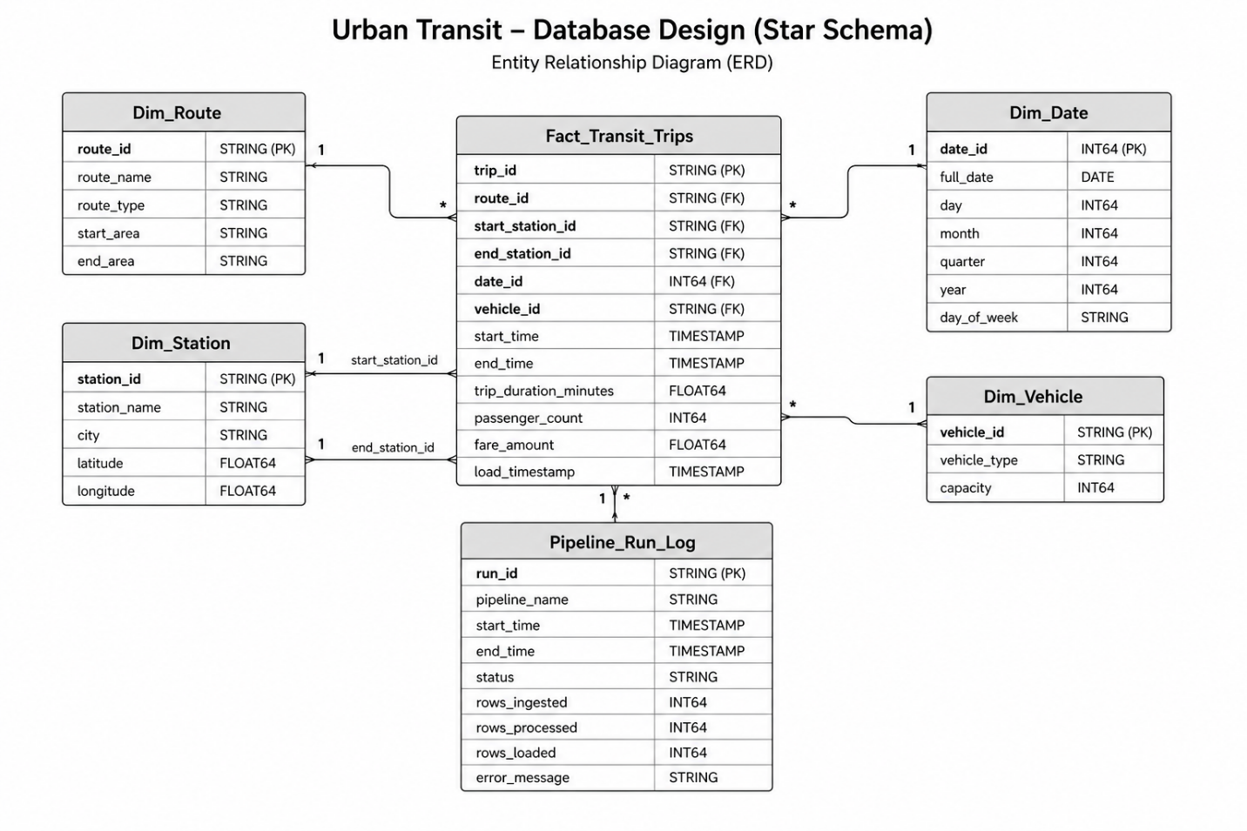
4.5.6 Physical Schema Considerations
In BigQuery, the physical design should support efficient storage and querying.
Recommended design:
- Store final processed tables in BigQuery.
- Use Parquet as the intermediate optimized storage format.
- Partition the fact table by full_date or load_timestamp.
- Cluster the fact table by route_id, start_station_id, and end_station_id.
- Keep pipeline logs in a separate monitoring table.

4.5.7 Normalization Considerations
The model is partially normalized using dimension tables to reduce repeated descriptive data. However, because the system is designed for analytics, it follows a Star Schema rather than full normalization.
This approach improves:
- Query simplicity
- Dashboard performance
- Data consistency
- Analytical flexibility
4.6 Data Flow & System Behavior
This section presents the dynamic behavior of the ETL system through multiple diagram types, including Sequence Diagram, Activity Diagram, State Diagram, and Class Diagram. Each diagram illustrates a different perspective of how the system operates during pipeline execution.

4.6.1 Sequence Diagram – ETL Execution
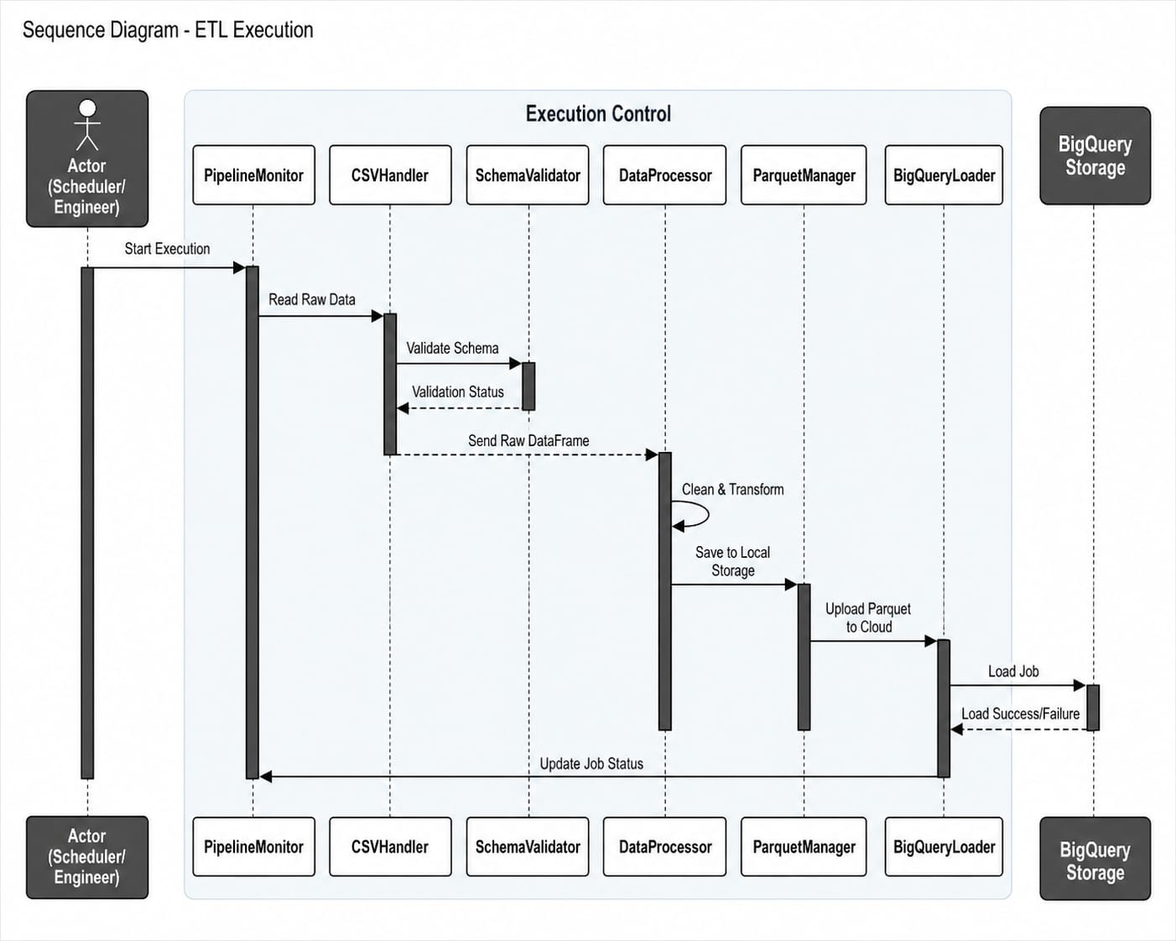
The Sequence Diagram illustrates the interaction between system components during the execution of the ETL pipeline.
The process starts when the Scheduler or Data Engineer initiates the pipeline execution. The request is received by the Pipeline Monitor, which coordinates the workflow across different components.
The CSV Handler reads the raw data from the data source and passes it to the Schema Validator, which verifies the structure and correctness of the data. Once validated, the dataset is forwarded to the Data Processor, where cleaning and transformation operations are applied.
After processing, the data is passed to the Parquet Manager, which converts and stores the data in Parquet format. The Parquet file is then sent to the BigQuery Loader, which uploads the data into BigQuery storage.
Finally, the system updates the pipeline execution status and logs the result (success or failure) through the monitoring component.
This sequence clearly shows a step-by-step interaction between all major components in the ETL workflow.
4.6.2 Activity Diagram – ETL Pipeline Flow
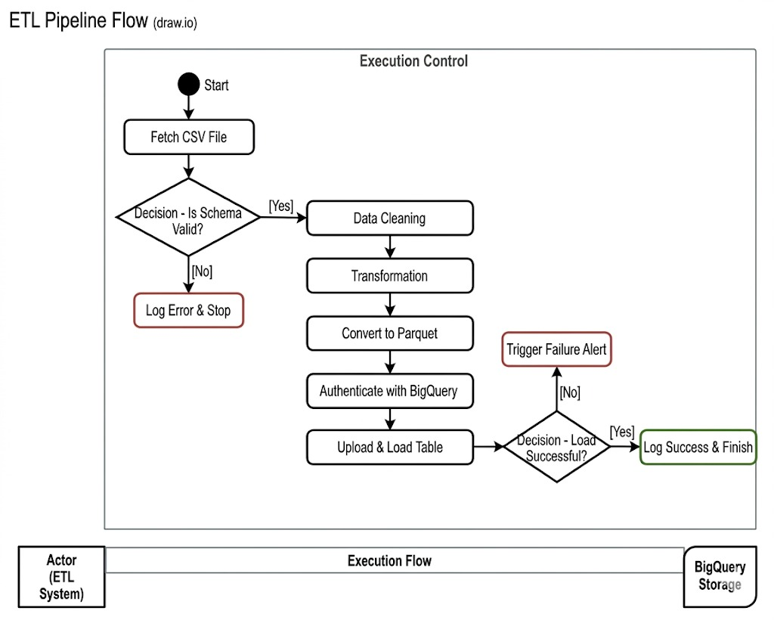
The Activity Diagram represents the workflow logic of the ETL pipeline from start to finish.
The process begins with fetching the CSV file, followed by a decision point to validate the schema. If the schema is invalid, the system logs an error and stops execution.
If the schema is valid, the system proceeds with data cleaning and transformation. The processed data is then converted into Parquet format.
Next, the system authenticates with BigQuery and uploads the data. A final decision point checks whether the loading process was successful.
If successful, the system logs completion and ends execution. If not, a failure alert is triggered.
This diagram highlights the logical flow and decision points within the pipeline.
4.6.3 State Diagram – Pipeline Execution States
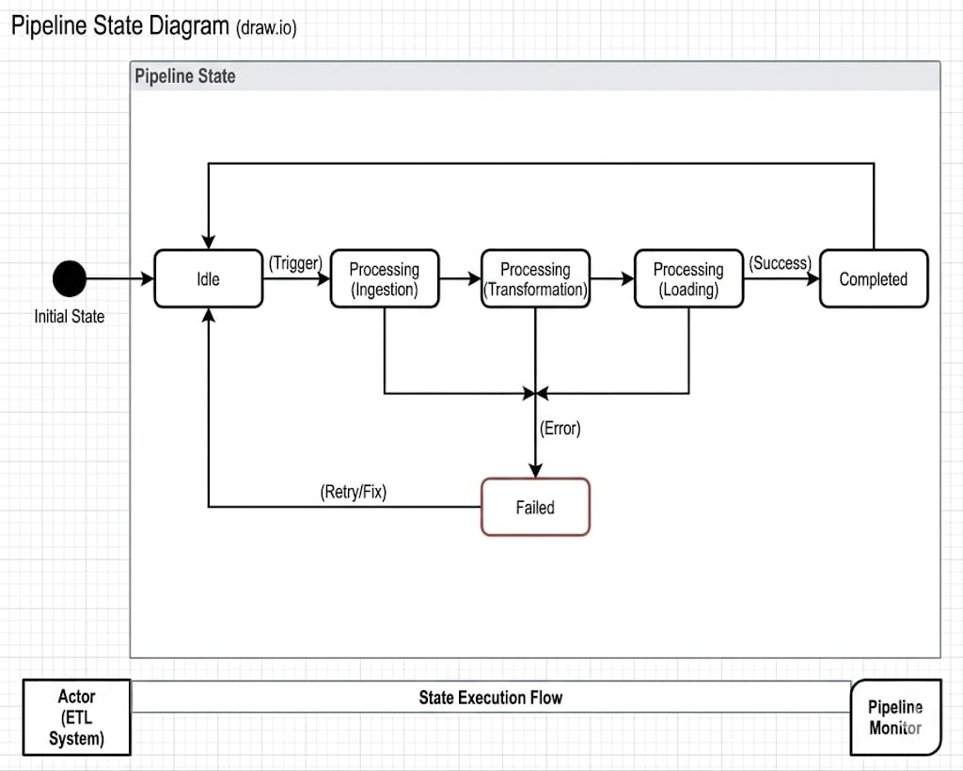
The State Diagram shows the different states of the ETL pipeline during execution.
The system starts in the Idle State. Once triggered, it transitions to Processing (Ingestion), followed by Processing (Transformation), and then Processing (Loading).
If all stages complete successfully, the system transitions to the Completed state.
If an error occurs at any stage, the system transitions to the Failed state. From there, it can either retry or return to the Idle state after resolving the issue.
This diagram helps visualize how the system behaves under both normal and failure conditions.
4.6.4 Class Diagram – Data Model Structure
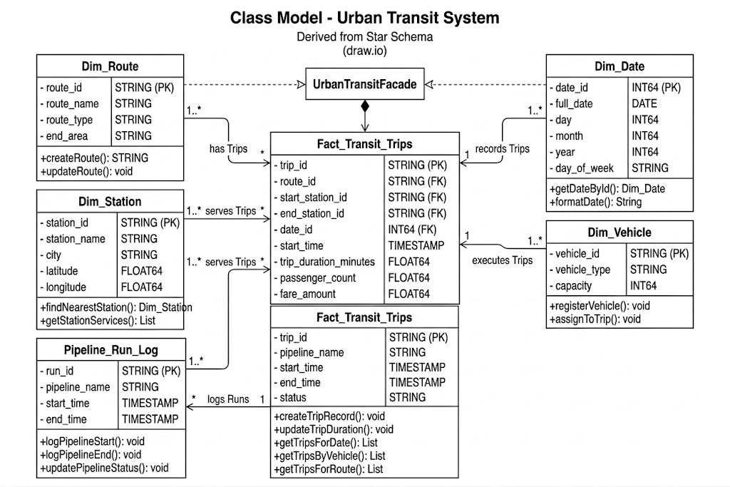
The Class Diagram represents the structural design of the system based on the analytical data model.
The central class is Fact_Transit_Trips, which stores the main transactional data. It is connected to multiple dimension classes, including Dim_Route, Dim_Station, Dim_Date, and Dim_Vehicle.
Each dimension provides descriptive attributes used for analysis, while the fact table stores measurable values such as trip duration, passenger count, and fare.
The Pipeline_Run_Log class is responsible for storing metadata about each pipeline execution, including status, timestamps, and processing statistics.
Relationships between classes follow a one-to-many pattern, where each dimension can be associated with multiple records in the fact table.
4.7 Data Flow Diagrams (DFD)
4.7.1 DFD Level 0 – Context Diagram
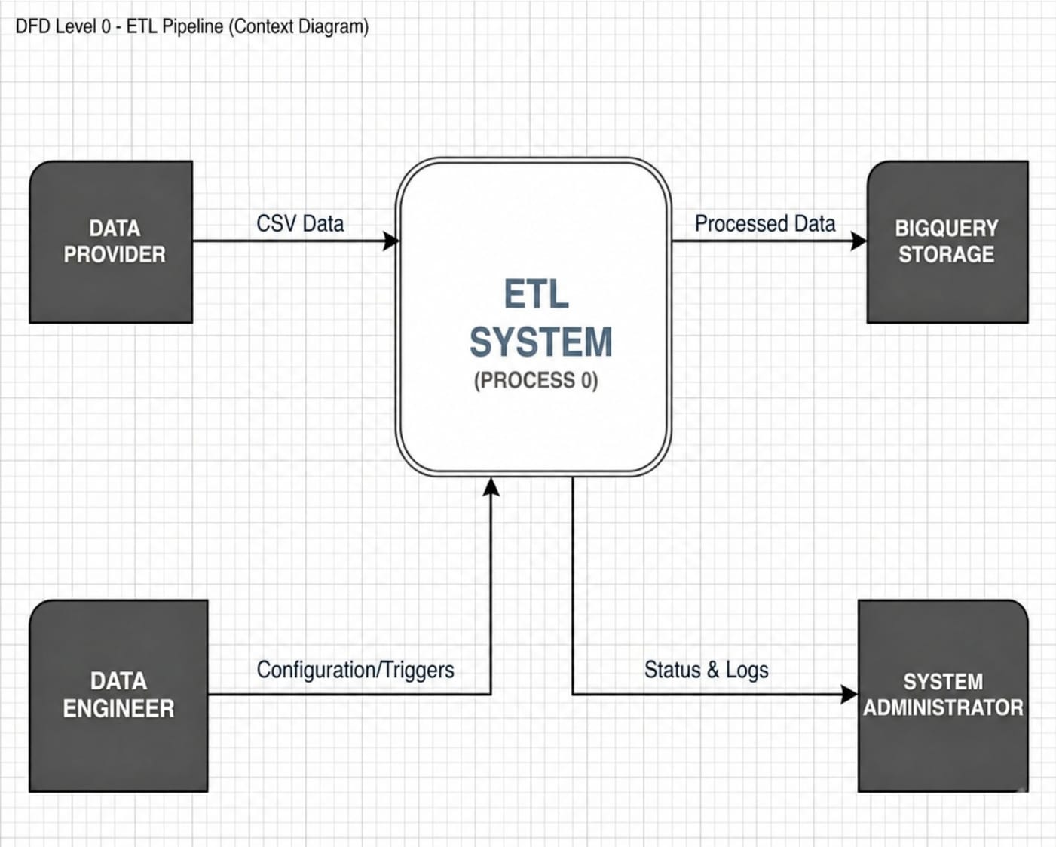
The Context Diagram represents the ETL system as a single process interacting with external entities.
The main external entity is the Data Provider, which supplies raw CSV data to the ETL system. The system processes the data and sends the output to BigQuery Storage.
The Data Engineer interacts with the system by providing configuration settings and triggering execution. The system, in return, provides status updates and logs to the System Administrator.
This diagram provides a high-level overview of system boundaries and external interactions.
4.7.2 DFD Level 1 – Process Breakdown
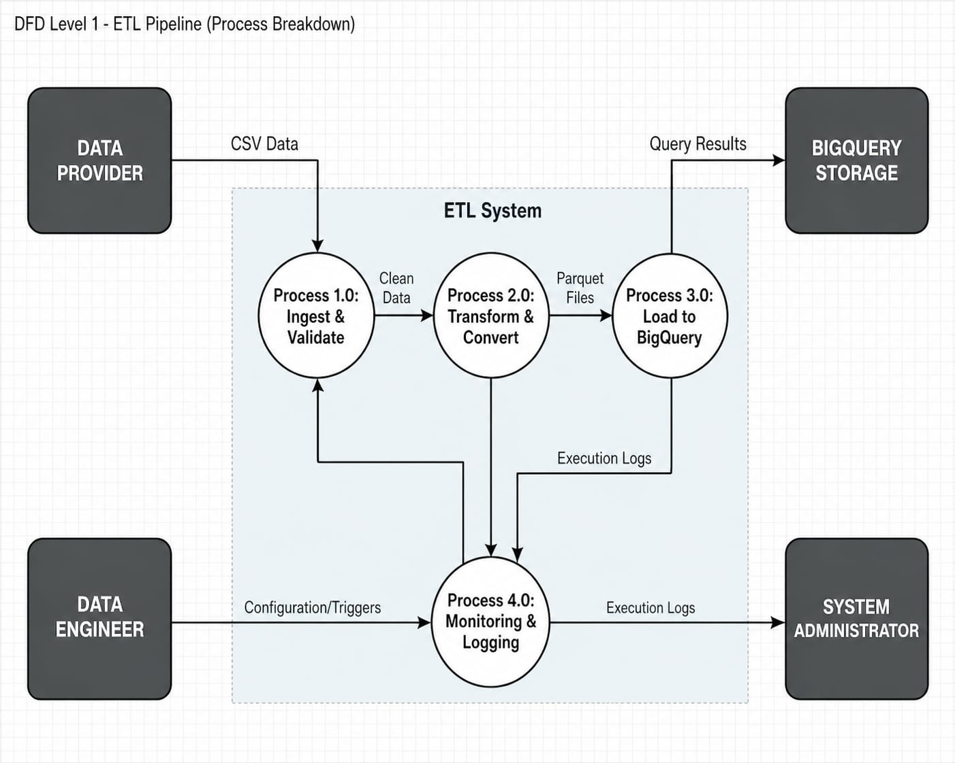
The Level 1 DFD expands the ETL system into multiple internal processes.
The system is divided into three main processes:
- Process 1.0: Ingest & Validate
This process reads CSV data and validates its schema before passing it forward.
- Process 2.0: Transform & Convert
This process cleans, transforms, and converts the data into Parquet format.
- Process 3.0: Load to BigQuery
This process uploads the processed data into BigQuery for storage and analysis.
Additionally, a fourth process:
- Process 4.0: Monitoring & Logging
This process collects execution logs and provides system status information.
Data flows between these processes in a sequential manner, while monitoring receives input from all stages and sends logs to the System Administrator.

